W2-S9 PRACTICE
Event & States

 At the end of his practice, you should be able to…
- Handle UI events (button click, text entered.)
- Use states hook to handle different variables (Boolean, string, number...) as states
- Using state hook to bind textfield
- Use state hook to display color conditionally

 How to work?
- Download the start code from the Google classroom
- For each exercise you can either:
  - Run npm install
  - Or move an existing node_modules to the exercise folder (fastest option!)

How to submit?
- Create a repository on GitHub with the name of this practice:
Ex: C2-S6 PRACTICE
- Push your final code on this GitHub repository (if you are lost, follow this tutorial )
- Finally submit on Google classroom your GitHub repository URL
Ex: https://github.com/thebest/ C2-S6 PRACTICE.git

 Are you lost?
You can read the following documentation to be ready for this practice:
https://www.joshwcomeau.com/react/data-binding/
https://react.dev/learn/responding-to-events

EXERCISE 1
The goal of this app is to manage the weather, which can be either sunny or raining!
As you can see in the picture, you need to change both:
- The main element background color (yellow or blue)
- The h1 element title (sun time, rain time)

Step 1: you need a state hook with a Boolean value: isRaining
- If this state is true, then the weather is raining
- If this state is false, then the weather is not raining (it’s sunny)

Step 2: Then you need to handle the 2 buttons events
- Click on Sunny time -> change the state to false (it’s sunny)
- Click on Rain time -> change the state to true (it’s raining)
Note: use the 2 functions already created to handle this.

Step 3: The last step if to update the <main> background and the <h1> text according to the isRaining state
- For the background color, you can use the (index.css) style classes: sunny and rainy
- You can to put the logic of your code in functions and bind your JSX properties with them

The finished app will look like this:
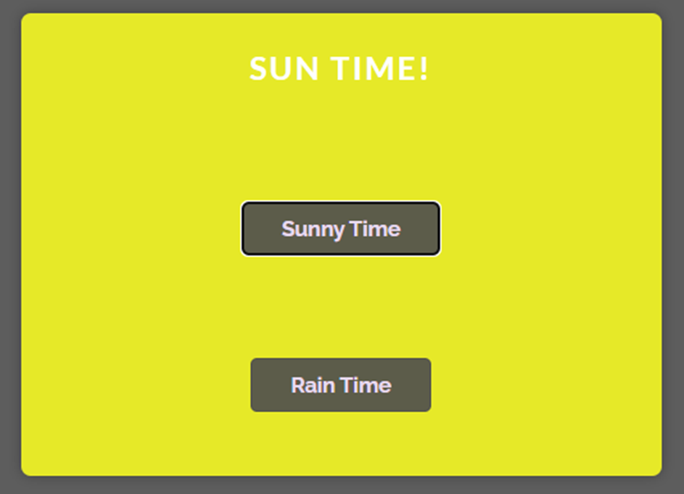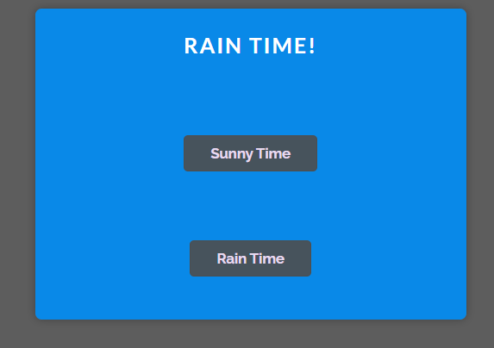

EXERCISE 2
The goal of this app is to convert some text entered in the textfield to upper case.

Step 1: Handle the textfield event when a key is pressed
- How to handle a key pressed event?
- Create a function to handle this event and write something on the console to test it.

Step 2: You need to use a state to keep the value of the text entered
  - What will be the type of this state? What will be the default value?
  - How to update this state with the current textfield value? And when?

Step 3: Finally display the text in lower case in the second textfield

The finished app will look like this:
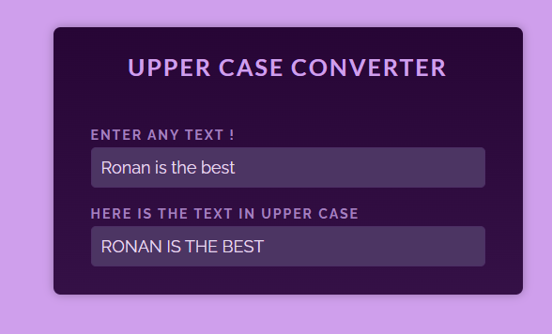

EXERCISE 3
The goal of this app is to add 2 numbers when the user clicks on the COMPUTE button.
- If the textfields do not contain numbers, you need to display a red warning (see the pictures).

Warning: you should have succeeded exercise 2 before starting this one!

You should think about the below question before starting your code:

- How many states do you need?
- How to check if a text is a number?
- How to manage the red color conditionally? (when the result is a warning)
- When you click on compute button,
  - What will you check?
  - How many states will you update?

The finished app will look like this:
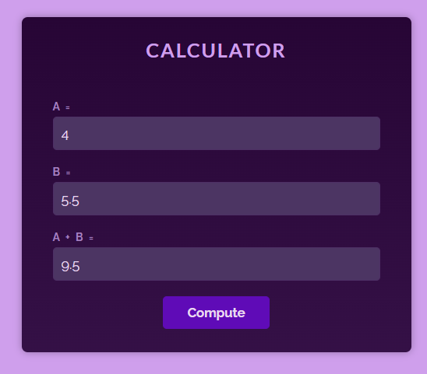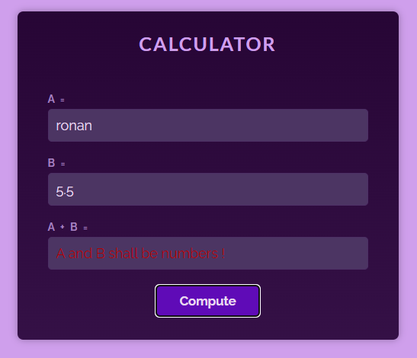

EXERCISE 4
The goal of this app is to manage a carousel of images
- Images shall change when clicking on left or right buttons
- The carrousel must loop:
  - Clicking right on last image, will go to the first image
  - Clicking left on first image, will go to the last image

Images
All images are in /asset folder
We provide imagesData.js with the list already defined.

Components
The component Carousel gets as prop the list of images to display. Your work will be on this component!
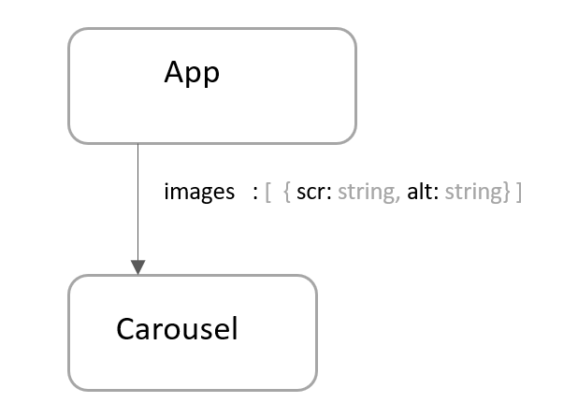
You should think about the below question before starting your code:
- How many states do you need?
- How to manage the current image?
- How to manage the cases when we are on the last image or first image?

Explore React Icon
- This project is using an extra library: react-icons: don’t forget to run npm i to install this library
- If you want to know how to use icons: https://www.geeksforgeeks.org/reactjs-icons/



